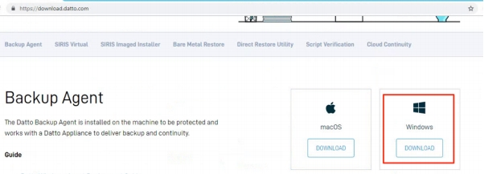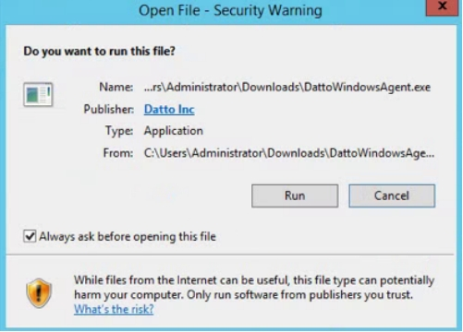

**Install Datto Windows Agent and add agent on**

**Datto**

**Agent Installation**

1. Download the new datto Windows agent installer from link <https://download.datto.com>click download for Windows.

2. When the installer finishes downloading, run the executable with Administrator privileges. Running the installer without elevated privileges may result error.

1

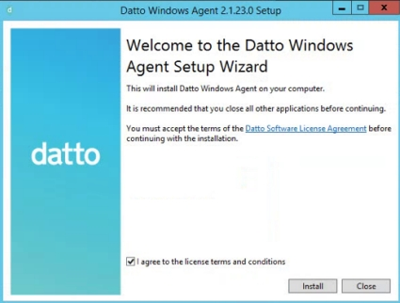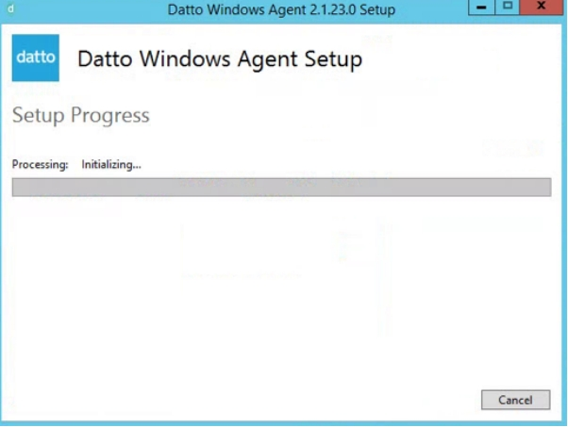

3. Click I Agree then click install

Install in progress

2

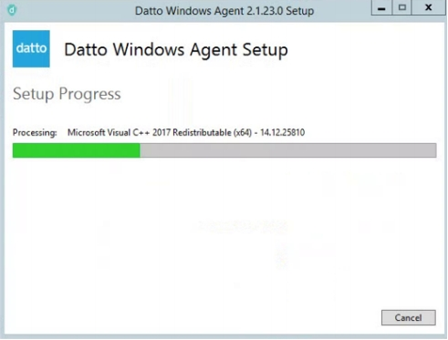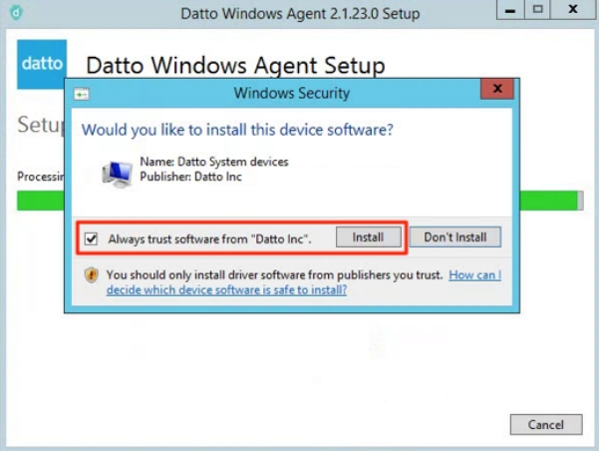

4. Click Install

3

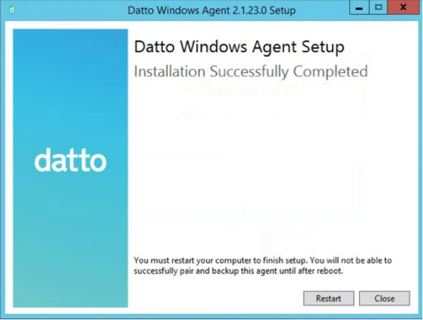

5. Installation completed, you must restart your computer, Backups will not function until the system has been rebooted.

You are now able to pair the protected machine with the SIRIS device and proceed to start backups .

While you can schedule a reboot later, you will need to reboot before the backup driver can be loaded. At his time, you may pair the agent to the Datto device and begin configurations. However, backups will not run until after the reboot.

4

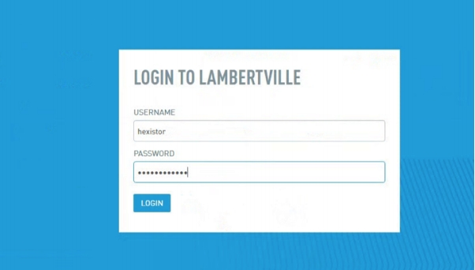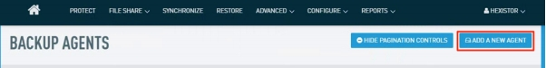

**Add agent on Datto Appliance.**

You can access this wizard from the web interface of Datto business continuity appliances, by access to your local IP address of your appliance.

1. Login to datto portal webUI

Figure 1: Login page

2. To start the Protect a System wizard, click on the Protect link in the web

interface of the Datto device, as shown in Figure 2

Figure 2: Protect tab

If this is the first agent on the device, you will see the window shown Figure 4. If this is not the first agent on the device, you will see a list of your agents and the Add a New Agent button in the upper right hand corner of the window.

5

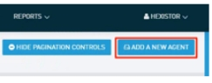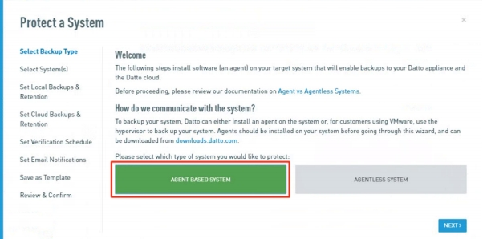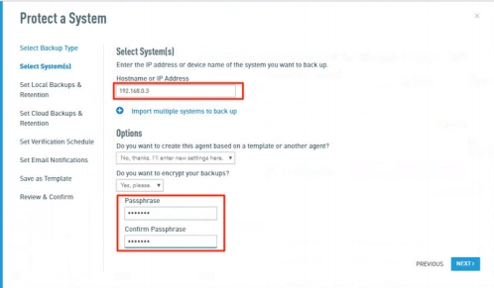

Figure 3: Add a New agent button

When you click the Add a New Agent button (or the Protect tab if this is your first agent), you will see the Protect a System screen shown in Figure 4.

Figure 4: Select backup type

3. If you are adding an agent-based system, click Agent Based System, and then click Next. You will see the window shown in Figure 5 to input IP address of your server/system that has been installed Datto Windows Agent.

Figure 5: IP Address

6

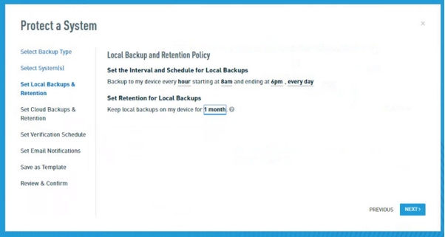

In the IP address or Hostname box, enter the address of the machine

that you would like to protect. Then, complete the following fields:

• Do you want to copy settings from an existing system?

This option allows you to use the backup settings from another

system that is already paired with your Datto appliance.

• Do you want to encrypt your backups?

This option allows you to encrypt the backups for the new agent.

If you choose the Yes option, you will be prompted to create a decryption passphrase for the agent.

After you finish configuring the agent's settings, click Next.

4. Local backup and Retention policy.

choose the schedule to back up the target machine to the Datto appliance from the drop-downs in the Set the Interval and Schedule for Local Backups fields. You can also check the box next to the Saturday and Sunday backups should be performed field to set a weekend backup schedule for the agent or choose every day as shown capture 6, then set the retention for Local backup option, click Next.

Figure 6: Local backup and retention policy

7

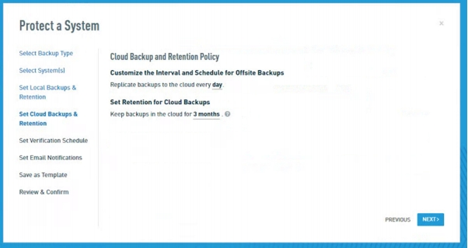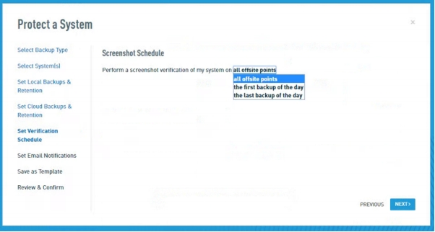

5. Configure the Cloud Backup and Retention Policy options, as shown in Figure 7. Then, click Next

then setting cloud retention

Figure 7: Cloud backup and retention policy

6. Configure the agent’s screenshot schedule, and click Next

Figure 8: Screenshot schedule

8

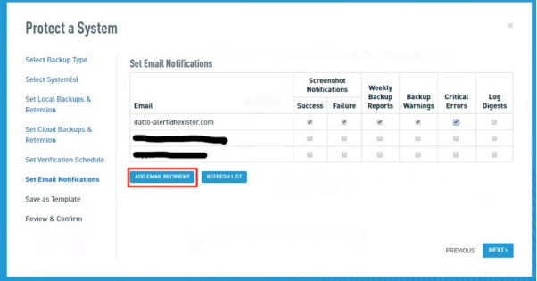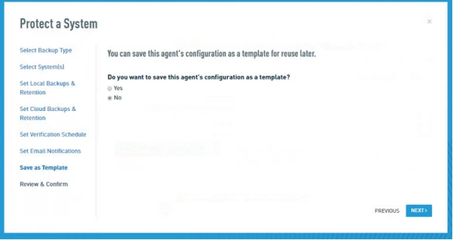

7. Set email notification by click Add email recipient.

Figure 9: Email address recipient

8. You can save the setting as your template or click no then click Next.

Figure 10: Set settings as template

9

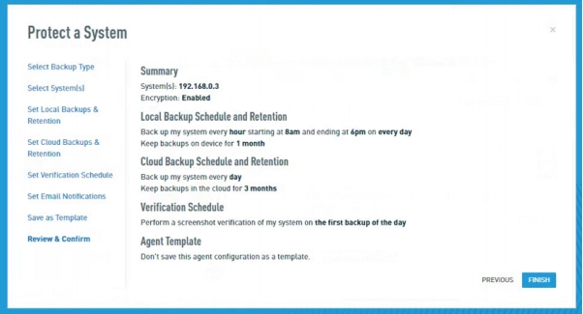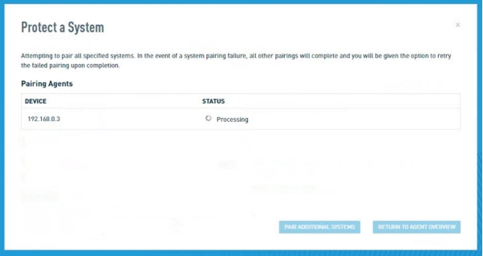

9. Confirm the agent’s setting. Then click finish.

Figure 11:Summary

Figure 12: Processing pairing agent

While the wizard is working to create the agent, the finish button will transform into a spinning gear icon. If the agent pairs successfully, you will be redirected to the protect tab of your Datto appliance ’s GUI, where you will see an entry for the newly-added agent as shown in figure 13.

10

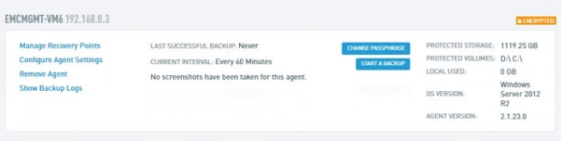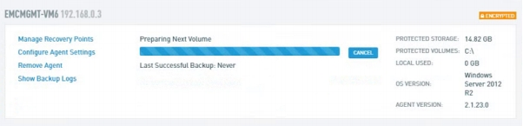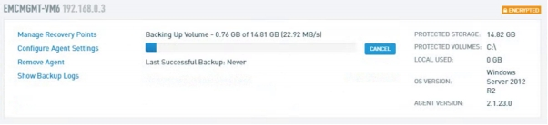

Figure 13: Agent Creation successfully

10. You can start run manual backup before schedule of to test a backup by click button start a backup.

Figure 14: Backup started

Figure 15: Backup in progress

11